<https://medium.com/better-programming/keeping-my-heroku-app-alive-b19f3a8c3a82>

Follow this link to get more detais

Add simple get request to your Homepage

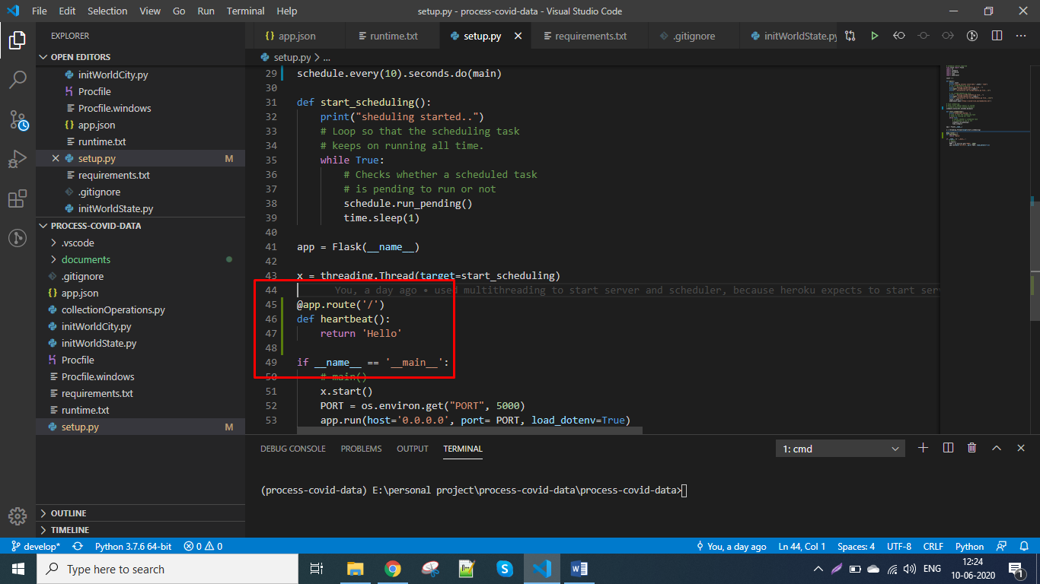

Signup on <https://cron-job.org/en/>

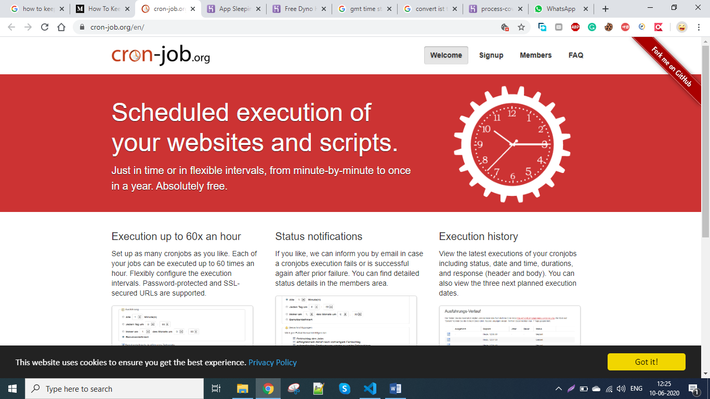

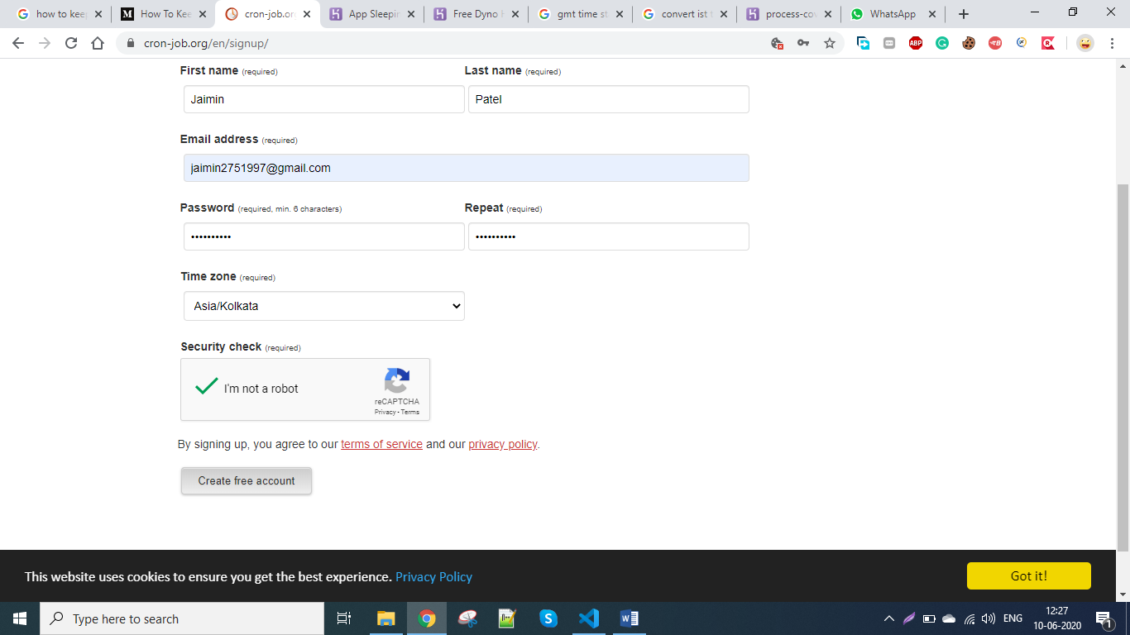

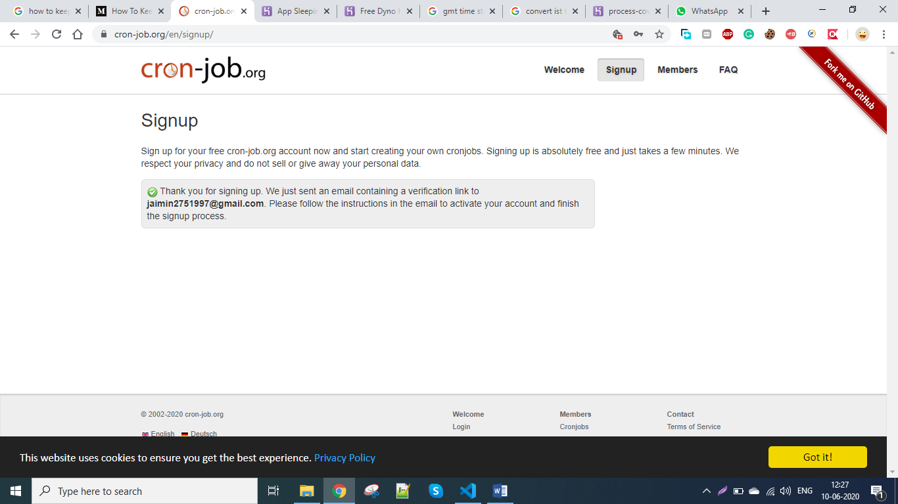

Verify link from mail account

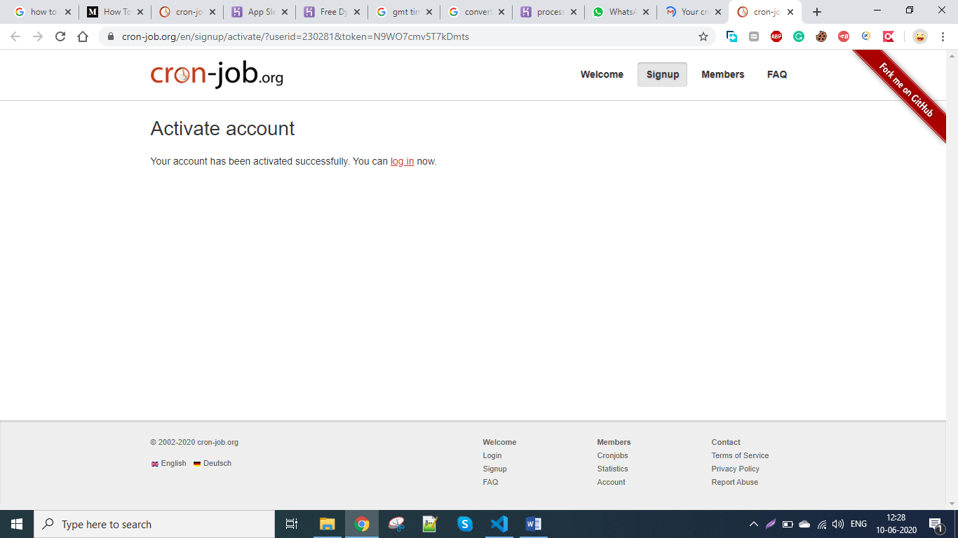

Click on log in

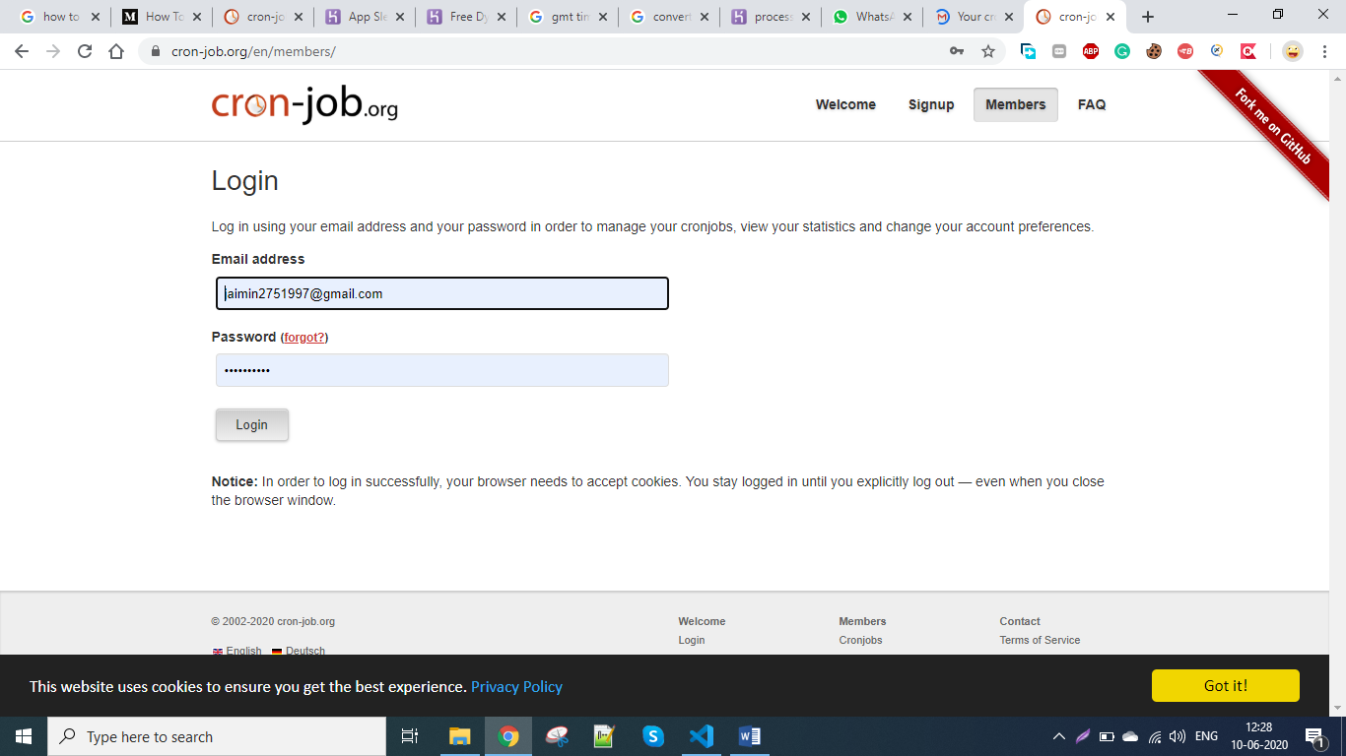

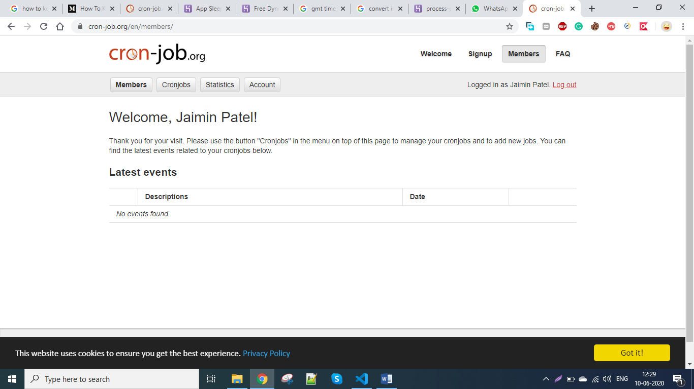

Create cron job

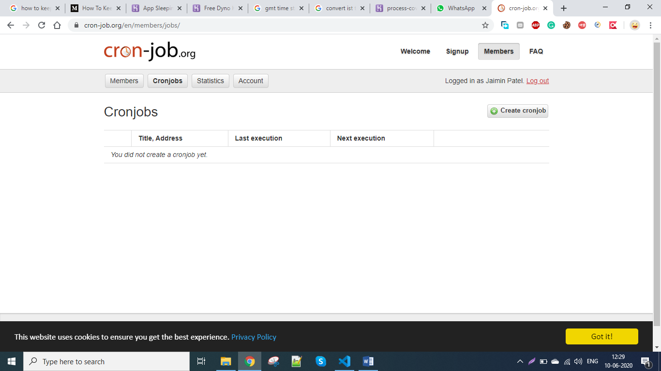

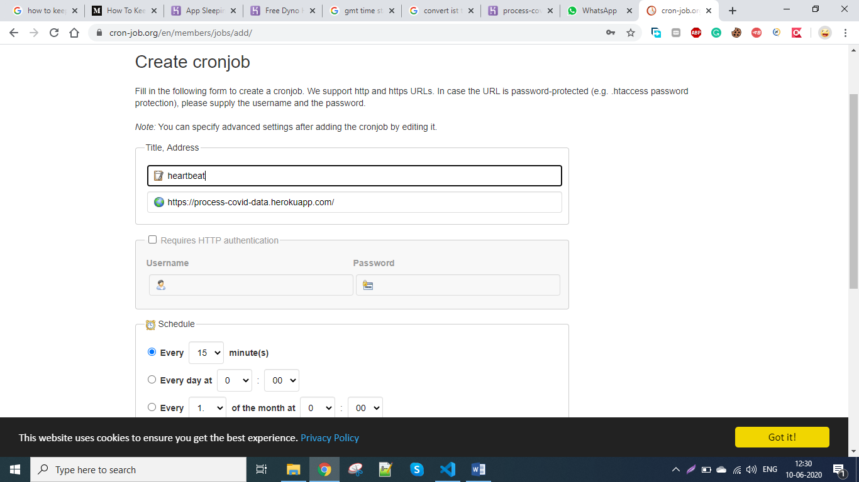

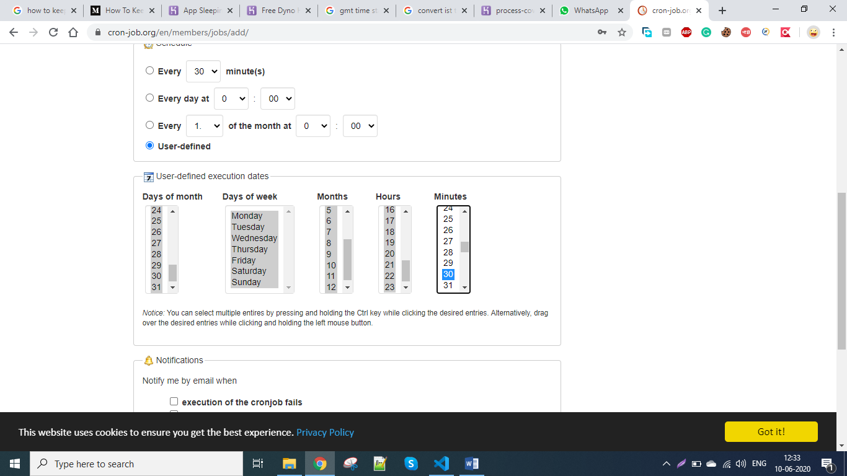

To click multiple number use control+click

Select all days of month

Select all days of week

Select all months

Select hours from 7 to 23 => 7 am to 12 am => 7 hour sleeping time is required

Semect minutes = 0 and 30 => means every 30 minutes it will send heartbeat

Now create cronjob

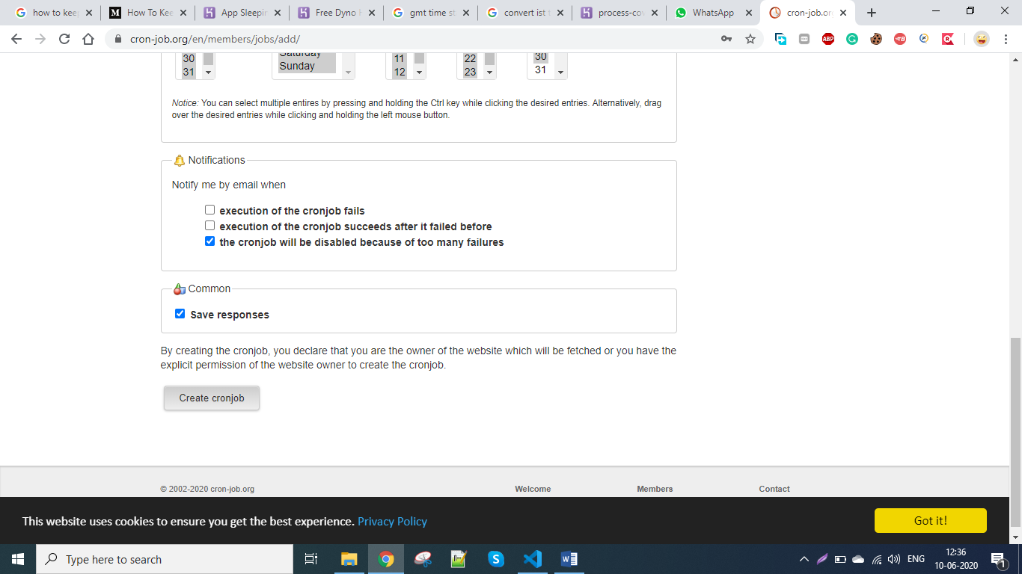

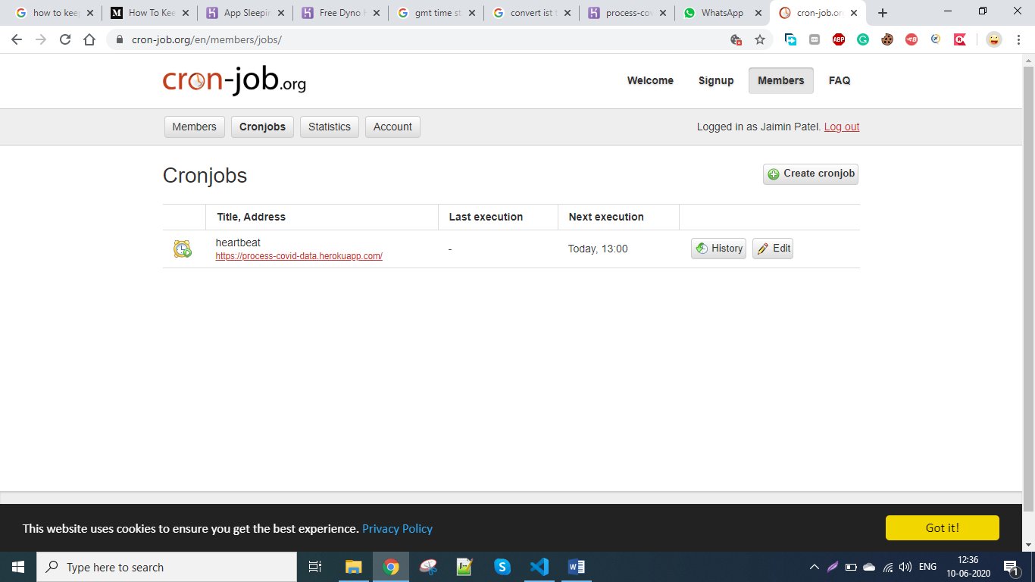

You can edit and see history